Annual PI Conference

Thursday 6 June 2019

Seminar Programme

Session 1  13:45-14:20 | A | An update for CAT lawyers | Paul Russell QC  & Niall Maclean
 | B | Landlord and tenant/DPA claims | Kweku Aggrey-Orleans  & Thea Wilson
 | C | Animals act: Paws for thought | Tom Banks
Session 2  14:25-15:00 | A | PI Life after Brexit | Phil Mead  & Ted Cunningham
 | B | Vicarious liability | David Sanderson  & Martina Murphy
 | C | What is dependency? | Harry Steinberg QC
Session 3  15:05-15:40 | A | Provisional Damages; all you need to know | Steven Snowden QC  & John-Paul Swoboda
 | B | TP rights against insurers claims | Mike Rawlinson QC  & Gemma Scott
 | C | Fundamental Dishonesty – an update | Ben Leech
TEA & COFFEE BREAK
Session 4  16:05-16:40 | A | CRU – the nitty and the gritty | Richard Viney  & Andrew Watson
 | B | Costs update | Andy Roy  & Helen Waller
 | C | Data Protection issues in PI claims | Craig Murray
Session 5  16:45-17:20 | A | The crossover between Clinical negligence and PI | Henry Charles
 | B | Capacity issues in severe brain injury claims | Pankaj Madan  & Dr Janet Grace
 | C | Relief from sanctions; where are we now? | Angela Frost
Session 6  17:25-18:00 | A | Budgeting top tips | Charlotte Reynolds  & Oliver Rudd
 | B | An Update on Motor Insurance | Stephen Worthington QC  & Isaac Hogarth
 | C | Contributory negligence | Dan Tobin  & Charley Turton

& Dr Janet Grace

A drinks and canapés reception will follow the conference from 18:00-20:30.

Annual PI Conference

Each delegate should choose one talk (A, B or C) in each session from the table below, please use the programme provided on the previous page for reference. Places will be allocated on a first come first served basis, and cannot be guaranteed.

 |  |  | Session
DELEGATE INFORMATION | Name | Email address | 1 | 2 | 3 | 4 | 5 | 6
 | 1. Click or tap here to enter text. | Click or tap here to enter text.
 | 2.Click or tap here  to enter text. | Click or tap here to enter text.
 | 3.Click or tap here  to enter text.  FREE | Click or tap here to enter text.
 | 4.Click or tap here  to enter text. | Click or tap here to enter text.
 | 5.Click or tap here  to enter text. | Click or tap here to enter text.
 | 6.Click or tap here to enter text.  FREE | Click or tap here to enter text.

Please complete below the information for us to provide an invoice
ORGANISATION INFORMATION | Contact name:
 | Contact email address:
 | Organisation name:
Address:
For invoicing
 | DX (if applicable):
 | Organisation type (Public or Private):
 | Payment Method (BACS or Cheque):

Before submitting this form, please make sure that all the
necessary fields are completed.

Subtotal
VAT (20%)
Total

Private firms
£95 plus VAT per delegate.

Public sector bodies (including academic institutions
& trade unions)
£75 plus VAT per delegate.

For every 2 places booked, receive a third free.
Annual PI Conference

VENUE

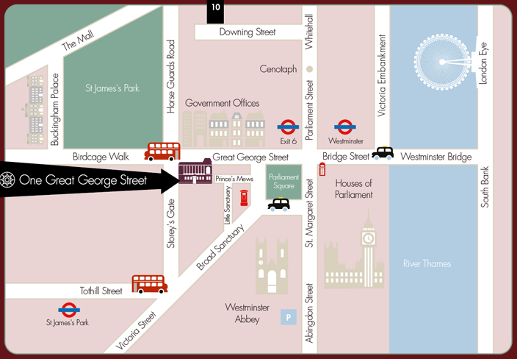

One Great George Street, Westminster,
SW1P 3AA

INFORMATION

Please e-mail this form as attachment to Ellen Ashman at ashman@12kbw.co.uk

To return by post, please send the booking form to:
Ellen Ashman 12 King’s Bench Walk, Temple, London, EC4Y 7EL. DX: 1037 London Chancery Lane.
For further information, please call 020 7415 8377
IMPORTANT: All bookings for 12KBW Events are bound by our Terms & Conditions (available online).

